**Project Design Phase -||**

**Data flow diagram and user stories**

|  |  |
| --- | --- |
| **Team Id** | **NM2023TMID22194** |
| **Date** | **02/11/2023** |
| **Project name** | **How to create a landing page on Hubspot** |

**Data flow Diagram:**

A data flow diagram is traditional and visual representation of the information flow with in a system a next clear depict the right amount of the system requirement graphically it shows how data enter and leaves the system. What changes of information what data to be stored.

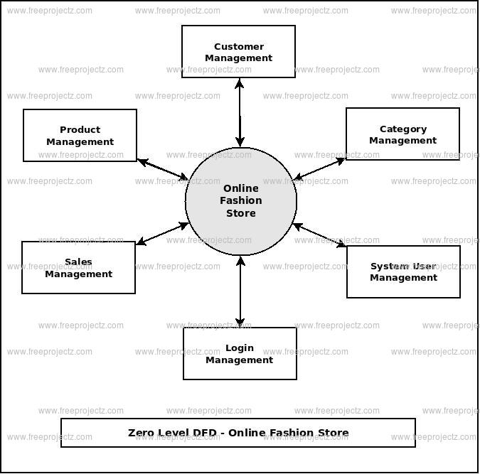

**User stories:**

|  |  |  |  |  |  |
| --- | --- | --- | --- | --- | --- |
| **User type** | **User requirements** | **User story**  **Number** | **User story/task** | **Acceptance criteria** | **Team member** |
| customer (Mobile user) |  | USN-1 | As a user, I can register for the application by entering my email, password, and confirming my password. | I can access my account / dashboard | Eswaran |
|  |  | USN-2 | As a user, I will receive confirmation email once I have registered for the application | I can receive confirmation email & click confirm | KRITHICK |
|  |  | USN-3 | As a user, I can register for the application through Facebook | I can register & access the dashboard with Facebook Login | MOHAMED SANAULLAH |
|  | Login | USN-4 | as a user, I can register for the application through Gmail | I can register through the gmail | SRIRAM SUNDAR |
|  | Dashboard | USN-5 | As a user, I can log into the application by entering email & password | I can register to email password | PAVITHRAN |
| Customer (Web user) | Website | USN-6 | User can login through the website | I can register through the website | MOHAMED SANAULLAH V |
| Customer Care Executive | Mobile/landline  number | USN-7 | User can contact the consultant | I can register through the number | Eswaran |
| Administrator | number | USN-8 | Service administration | I can access  Through service | KRITHICK |